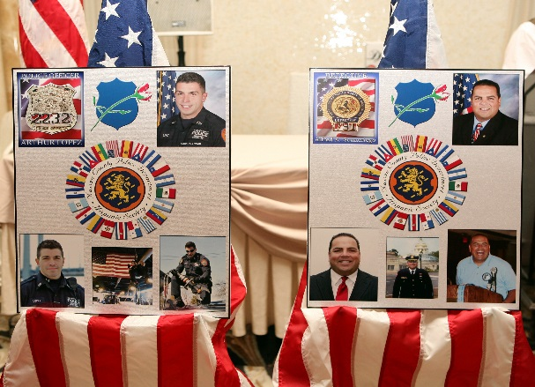

**Nassau County Police**

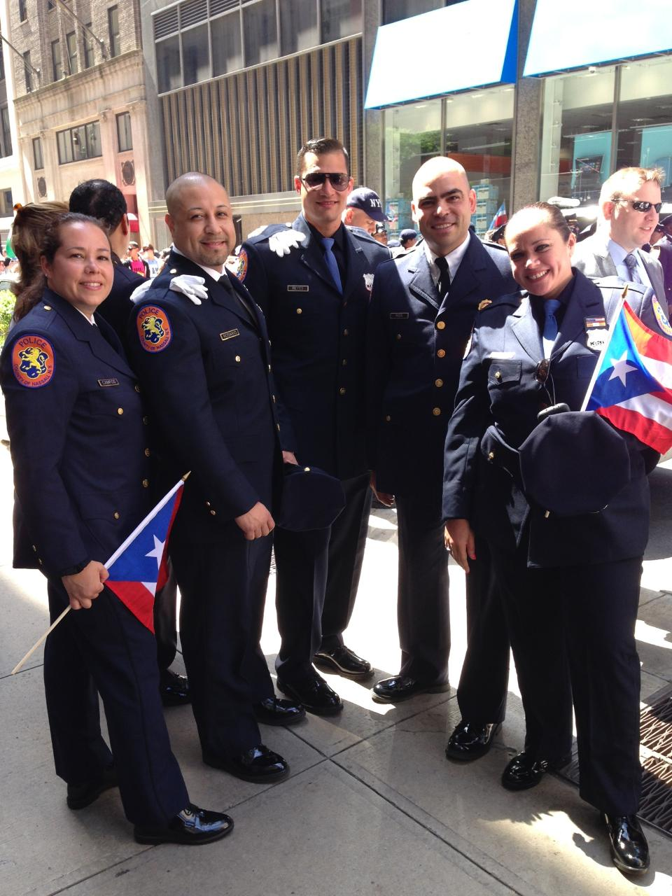

# *Hispanic*

***Society***

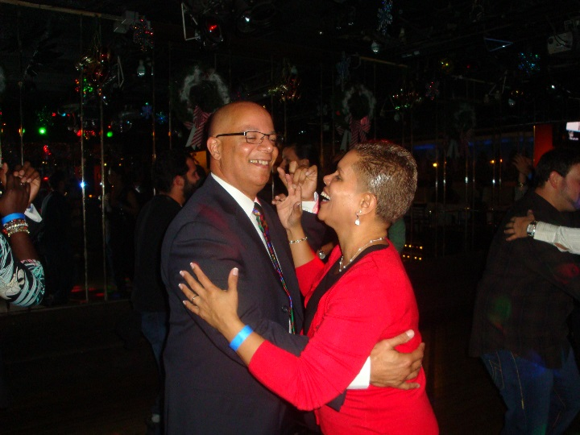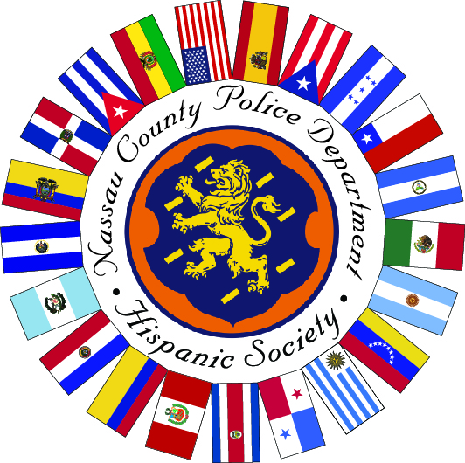

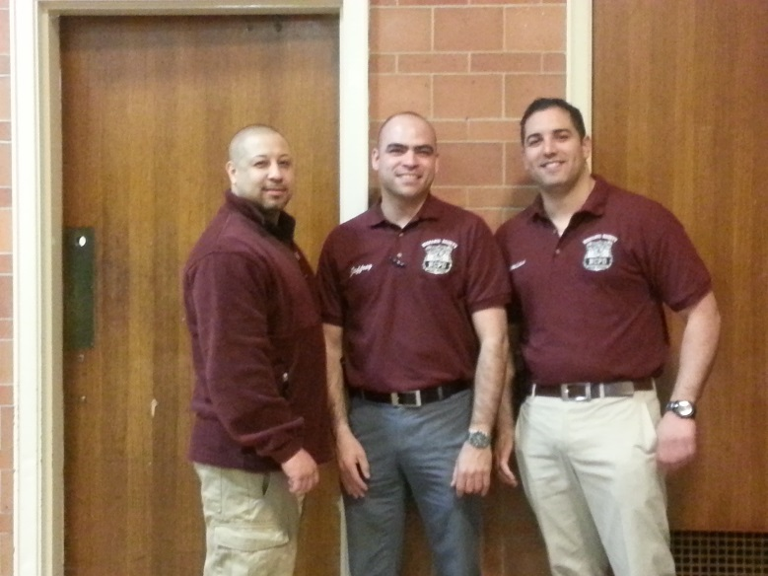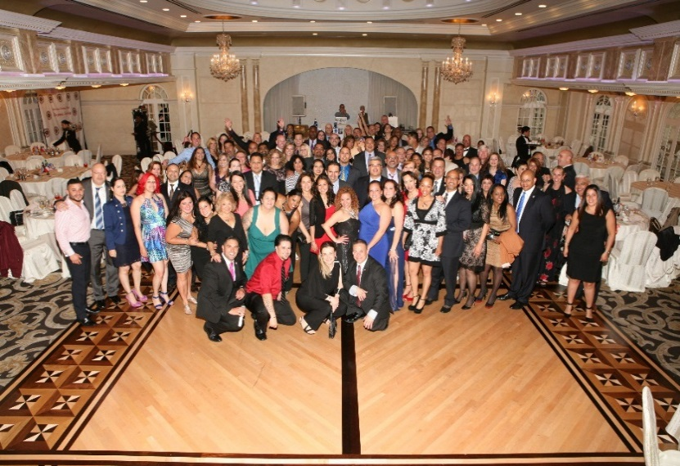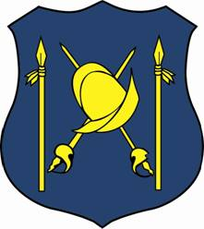

Unidos Progressamos

~

Together We Progress

HISPANIC SOCIETY

160 1st Street #566

Mineola, NY 11501

NCPDHispanicSociety@gmail.com



The Nassau County Police Hispanic Society is a fraternal organization that was founded for its members in order to foster a spirit of unity; to inspirea high sense of loyalty for our duties, our government and our department; to stimulate social, moral and intellectual advancement; as well as increase the relationship between the police departments of Nassau County and our Hispanic Communities.

**Meetings are held the last Tuesday of the month, with the exception of July & August. Contact a board member or write to NCPDHispanicSociety@gmail.com for updated time and location of meeting, to request a membership application or to be added to our email list or text message blast. We have a number of social events to strengthen relationships within our membership, peers and our families:**

**Thanksgiving Fraternal Comedy Show Fundraiser, Three Kings Christmas Party & Scholarship Dinner Dance. We also join in the Hispanic Society events of the NYPD, NYCD & Suffolk County as well as support our Nassau County fraternal brethren.**

**MEETINGS & EVENTS 2017**

January 5 – Three Kings Party

Jan 31 – Meeting

Feb 28 – Meeting & Dance Committee

Mar 28 – Meeting

Apr 25 – Meeting & Dance Committee

May 29 - Board & Dance Committee

June 1 - Dinner Dance in Lieu of Meeting

July & August – Summer Hiatus

We are looking to host a casual family event in the summer – karaoke, dominos tournament, softball game, bar crawl etc. Have Ideas?

September 26 - Meeting

November 2 – Comedy Fundraiser

Our new logo encompasses the Nassau County emblem surrounded by 20 flags from the Spanish speaking countries of the world.

These flags represent our Hispanic heritage.

The American Flag represents the

country which unites us.

Original logo of the NCPD Hispanic Society bearing a conquistador helmet and the spears representing the native peoples of Latin America

# We are an organization, comprised of sworn and civilian members of law enforcement agencies within Nassau County, most of which are of Hispanic descent.

# We are not exclusive of the heritage, but welcome all who have the same goals for the Hispanic Community that we serve.

# Increased membership and involvement allows our organization to prosper.